Scone Recipe
Ingredients
- 225g self-raising flour 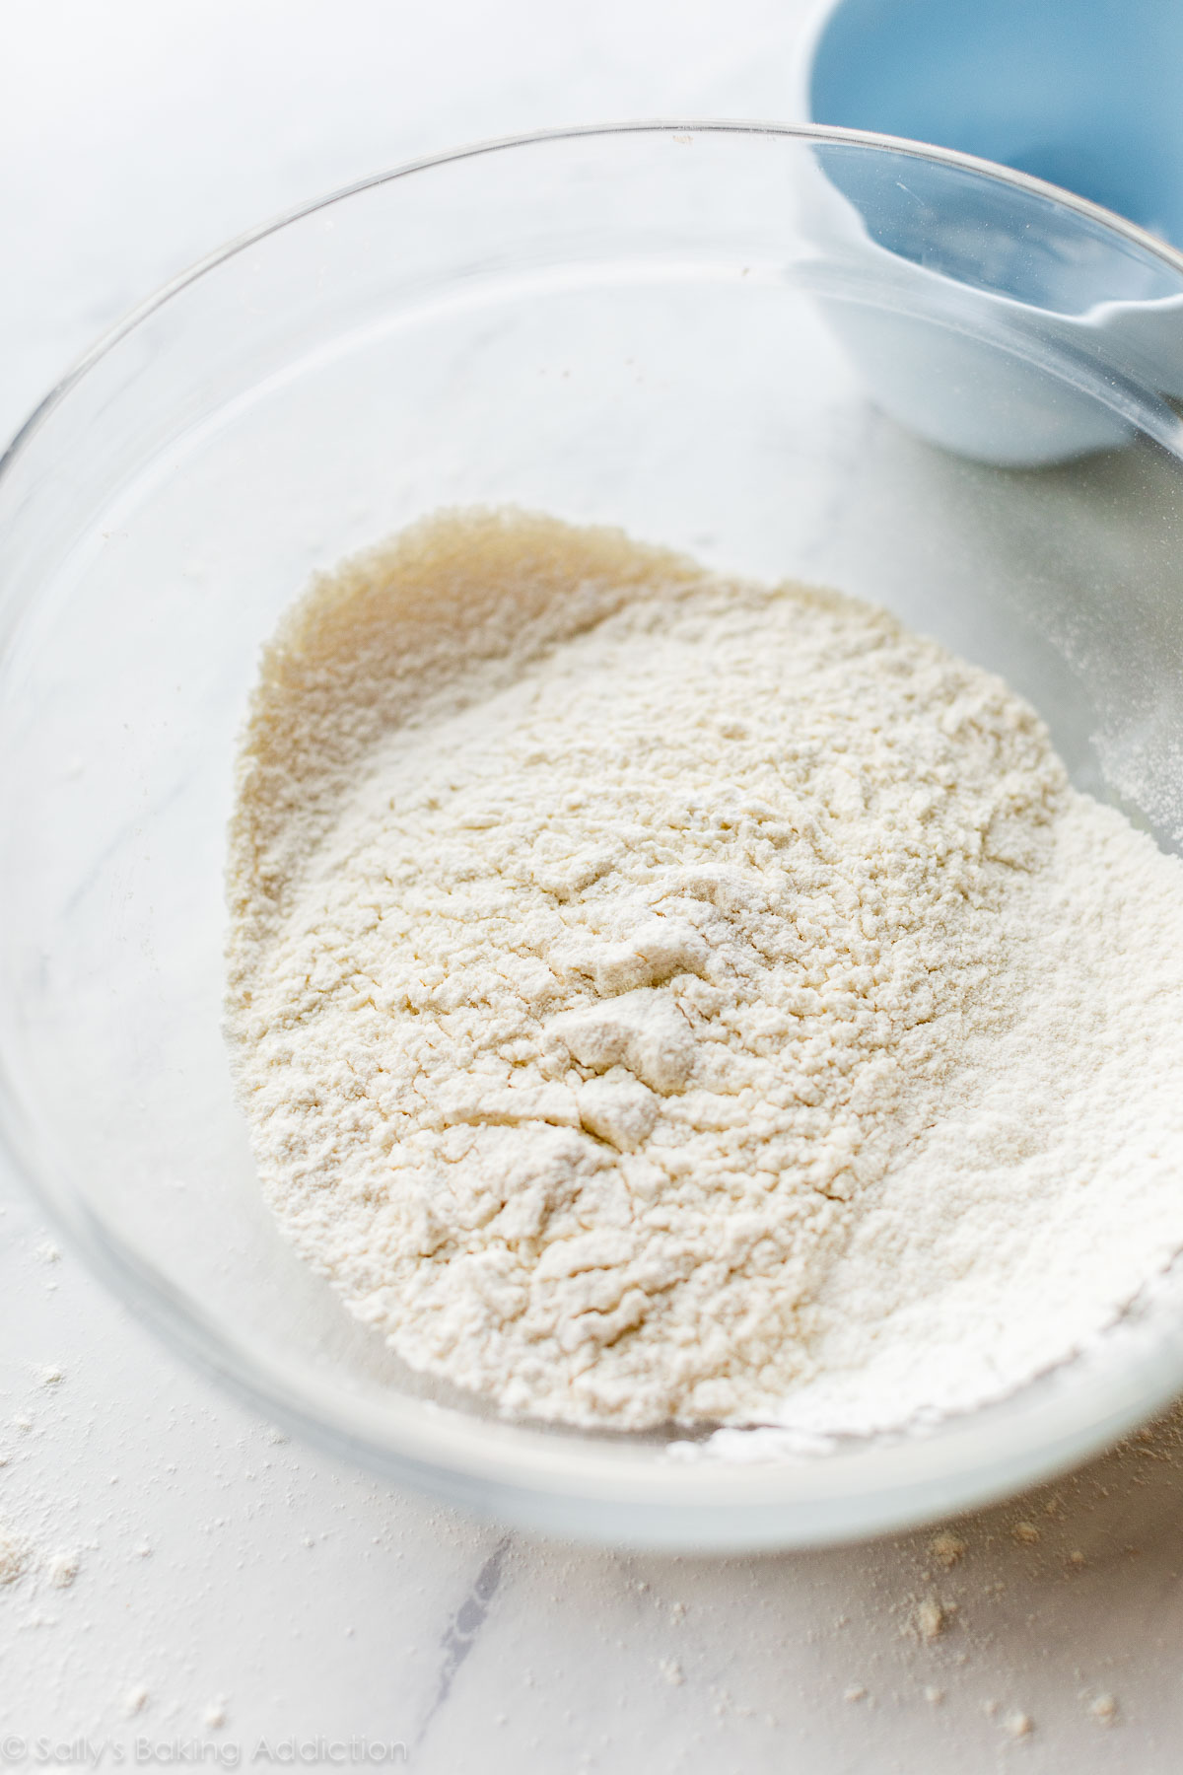
- A pinch of salt
- 55g butter 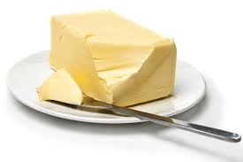
- 25g caster sugar
- 150ml milk
- 1 egg to glaze 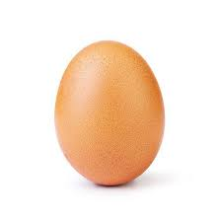
- **Optional extras** 3 handfuls of either currants/halved candied cherries/choc chips 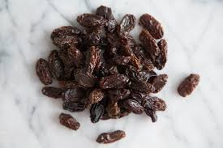
Baking tools
- Baking tray 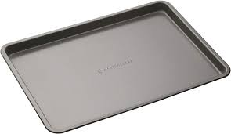
- Mixing bowl
- Whisk or fork 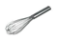
- Scales 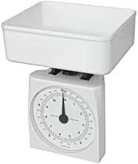
- Measuring jug
- Rolling pin 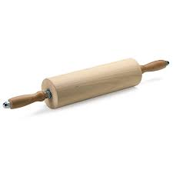
- Cookie cutter
- Cup
- Cooling rack 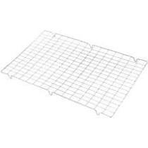
Method
1. Heat the oven to 220C/200C Fan/Gas 7. 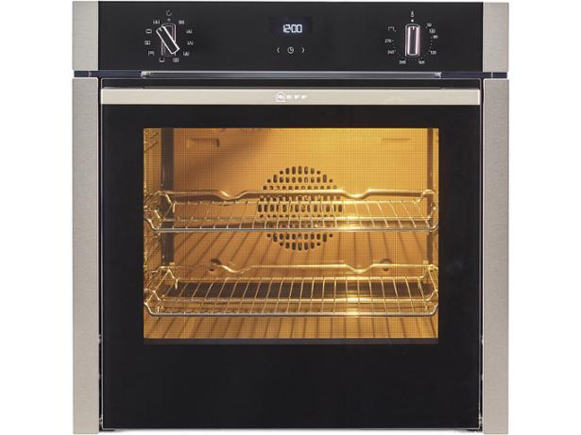
2. Lightly grease a baking tray with small amount of butter. 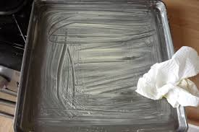
3. Mix together the flour and salt in a bowl. 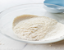 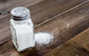
4. Rub in the butter with flour and salt. 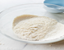
5. Then add the sugar and stir.
6. Add the milk to get a soft dough.
7. Lightly flour the work surface and lightly knead the scone dough. 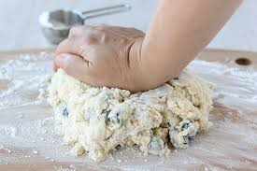
**Optional** add currants/halved candied cherries/choc chips 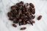
8. Roll dough to approx. 2cm thick. 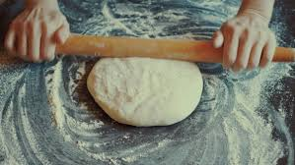
9. Cut circles approx. 5cm and place on a baking tray. 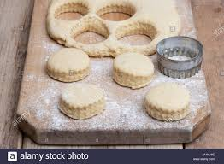
10. Beat egg in a cup and then use to coat the top of scones. 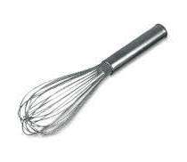
11. Bake in oven for 12-15 minutes, until golden brown. 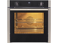
12. Cool on a wire rack.
Can be served with butter and jam and maybe some clotted cream. ENJOY!!

